SQL Server 2016 Standard Build

Enterprise 64-bit

Step by step instructions for standard SQL 2016 setup

Prepared by:
HSSBC Database Services
January, 2016

©2010 BCHA SSO; this document is the property of British Columbia Heath Authority Shared Services Organization and is for reference only. It is not to be reproduced or distributed in any way without the express written consent of BCHA SSO. Other brands and names are the property of their respective owners
Table of Contents

SQL Server 2016 Standard Build 1
Enterprise 64-bit 1
Prepared by: 1
1 Document Version 4
2 Prerequisites for installation 5
2.1 Disk drives and folders 5
2.2 Storage type and LUN configuration 5
2.3 Software Requirements 6
2.4 Adjust local security policy rights for SQL service account 7
2.5 Set user as local admin on PHSABC domain 7
3 SQL Server 2016 Setup 8
3.1 Locate and run Setup.exe 8
3.1.1 Product Key 9
3.1.2 License Terms 10
3.2 Feature Selection 12
Instance Configuration 15
3.3 PolyBase Configuration 16
3.4 Server Configuration 16
3.4.1 Service Accounts Tab 16
3.5 Database Engine Configuration 19
3.5.1 Account Provisioning 19
3.5.2 Data Directories 20
3.6 TempDB Optimization 20
3.6.1 FILESTREAM 23
3.7 Analysis Services Configuration 24
3.7.1 Account Provisioning 24
3.7.2 Data Directories 25
3.8 Reporting Services Configuration 26
3.9 Microsoft R Open feature 27
3.10 Feature Configuration Rules 27
3.11 Ready to Install 29
Complete 30
3.12 Install SQL Server Management Tools 30
3.13 Service Pack Install 33
3.13.1 Pre-update checks 34
3.13.2 Accept License Terms 35
3.13.3 Select Features 36
3.13.4 Files in Use Check 37
3.13.5 Verify and Start 38
3.13.6 Complete SP installation 39
3.13.7 Manual change for SSRS 39
4 SQL Server 2016 Configuration 40
4.1 TCP/IP Port Setting 40
4.2 Memory Allocation 40
4.3 Database Settings 41
4.4 Model database optimization 41
4.5 Set up Standard Maintenance 42
4.6 uCMDB User 42
4.7 Restart SQL Services 42
4.8 Add Server to Inventory 43
4.9 Create Integration Services Catalog 44
4.9.1 Right click on the Integration Catalogs node and select Create Catalog. 44
4.10 Reporting Services 45
4.10.1 Open Reporting Services Configuration Manager 45
4.10.2 Backup Encryption Key 46
4.10.3 Upload Encryption Key file to Secret Server 48
4.11 Sharepoint 49

Document Version
Date | Changed By | Version | Description Of Changes
03/31/2016 | Jimmy Tong | 1.0 | Initial Version

Prerequisites for installation

Disk drives and folders

Each SQL Server must have the following disks dedicated to SQL Server service, recommended disk sizes are based on the total disk space required for data files:
- H (Data): 100%
- I (Log): 25% of Data
- J (TempDB): 25% of Data
- K (Backup): 150% of Data
In order to separate SQL related files from other files that might accidentally be saved on above disk drives, the folders below must be created prior to begin SQL setup:
- H:\SQL_Data
- I:\SQL_Log
- J:\SQL_TempDB
- K:\SQL_Backup
In case we are planning to install a second instance the next four disk drive will be:
- L (Data): 100%
- M (Log): 25% of Data
- N (TempDB): 25% of Data
- O (Backup): 150% of Data

Storage type and LUN configuration
Here is an outline of the storage type and LUN configuration for different disk drives; the following items should be already in place when the Windows server is built, and is only for the reference:
- 5 disks in total, C:/H:/I:/J:/K:
- Disks are grouped into 3 sets for performance and redundancy. C:/H:, I:/J:, and K:. i.e. 3 data stores to be used for each SQL server.
- I:/J: should be on a higher performance data store (i.e. RAID1, or faster disk group)
- Data stores of C:/H: and K: should be separated on different disk sets for redundancy. (e.g. different SAN, or different disk group, or different pool…etc.).

Software Requirements
- .NET Framework
require .NET Framework 4.6 for the Database Engine, Master Data Services, or Replication. SQL Server 2016 setup automatically installs .NET Framework.
- Windows PowerShell SQL Server 2016 does not install or enable Windows PowerShell 2.0; however Windows PowerShell 2.0 is an installation prerequisite for Database Engine components and SQL Server Management Studio.
- SQL Client Tools
require Internet Explorer to download the binaries. Minimum requirement is Window 10

Adjust local security policy rights for SQL service account
For any Windows operating system, on the Start menu, click Run.
- Type secpol.msc and then click OK. If the User Access Control dialog box appears, click Continue.
- In the Local Security Policy tool, expand Security Settings, expand Local Policies, and then click User Rights Assignment.
- In the results pane, double-click Generate security audits.
- On the Local Security Setting tab, click Add User or Group.
- In the Select Users, Computers, or Groups dialog box, either type the name of the SQL service account, such as domain1\user1 and then click OK, or click Advanced and search for the account.
- Click OK.
- Close the Security Policy tool.

Note:
This setting takes effect when SQL Server is restarted.

Set user as local admin on PHSABC domain
When you install SQL Server, the system grants Log On As A Service right to the service account. However, on PHSABC domain, Active Directory will come along 90 minutes later and take away this right and cause SQL Server to fail when it starts up again. Go to Run…, type lusrmgr.msc, click Groups, double click Administrators, and add the service account.

SQL Server 2016 Setup

Locate and run Setup.exe
While you are signed in the server as your SA account which must be a member of SR HSSBC SQL Admin (CrossHA) group, run SQL 2016 setup program.

Once SQL Server Installation Center window pops up, click on Installation link on the left, and select New SQL Server stand-alone… as shown below:

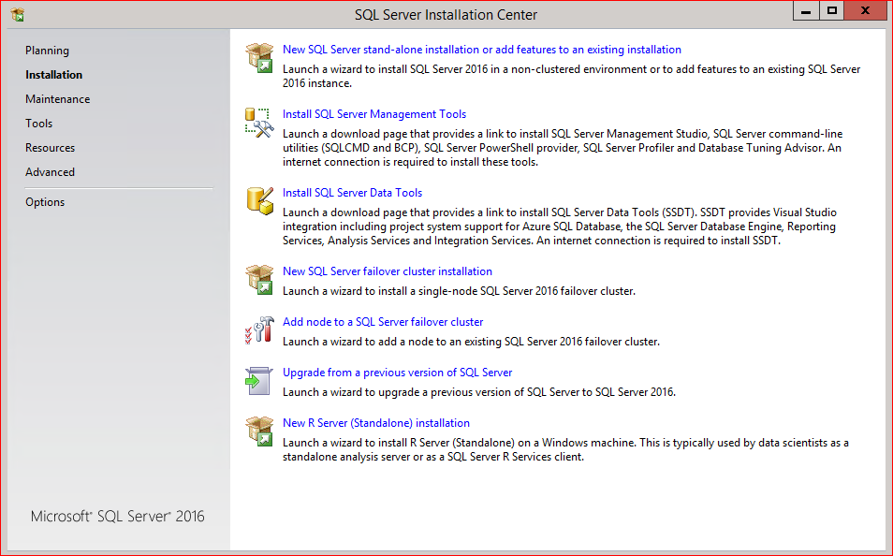

Product Key
Leave the default value for product key:
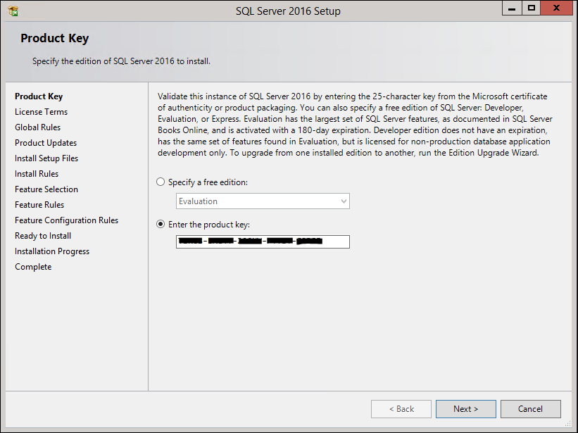

Press Next button.

License Terms
Check I accept the license terms as shown below:
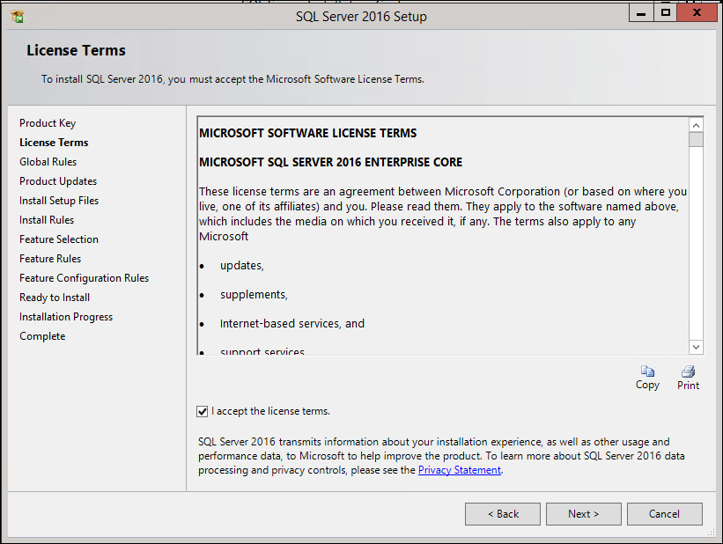
Press Next button.

The SQL Server 2016 Setup application will run multiple checks for rules during the installation process. If a rule check fails, the setup application will provide the corrective measures to take so installation may proceed. The setup application will also search for product updates.
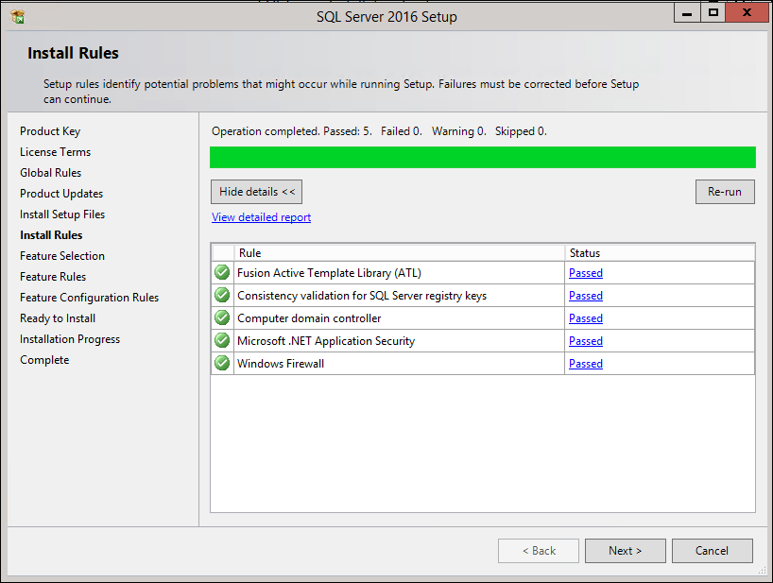
Press Next button.

Feature Selection
Select only the items required for this install, leave the default settings for Shared feature instance root directory text boxes:
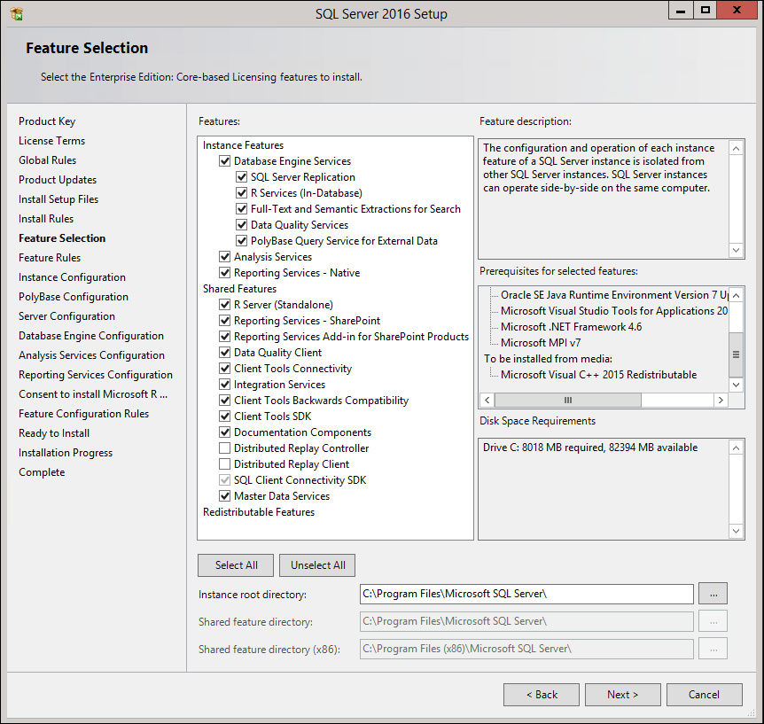
NOTE: SQL Server Management Tools and SQL Server Data Tools are separate install.
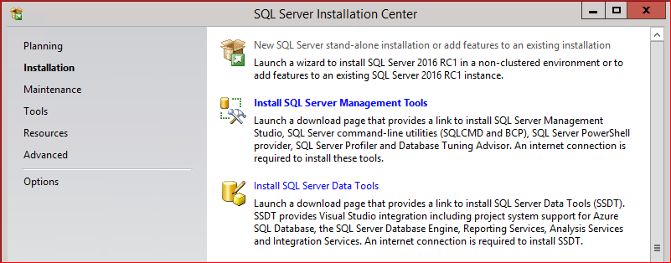
Wait until Feature Rules is completed, press Show details button and check the rules, if they are all passed as follows:
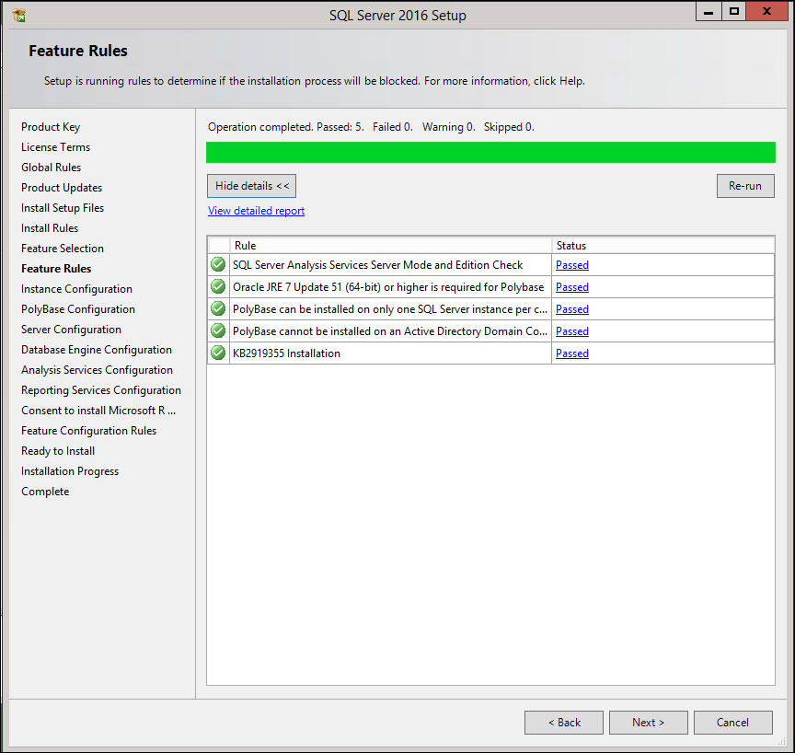

Press Next button.

Instance Configuration
Leave all the default settings and press Next button, in case a default SQL Server instance already exists, select Named instance option, and enter the instance name in the related text box:
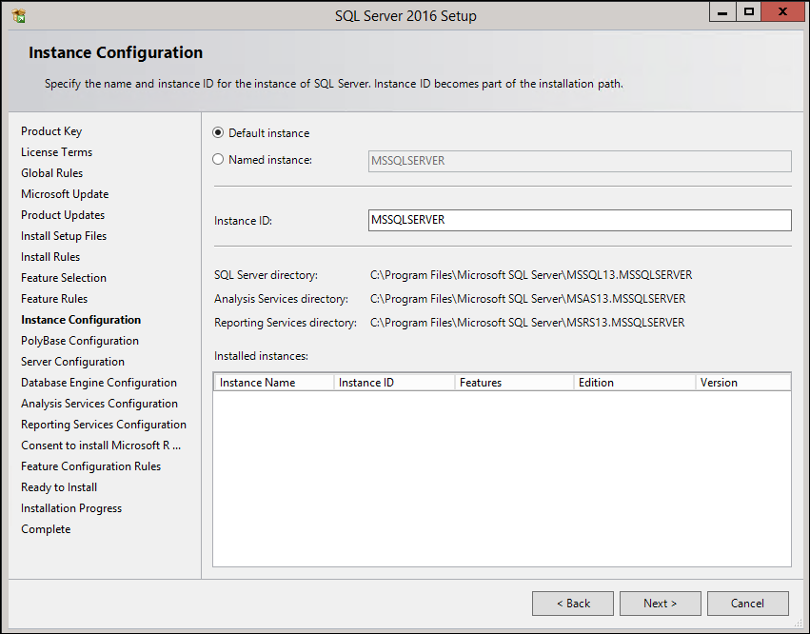

Press Next button.

PolyBase Configuration
Select the default as standalone PolyBase-enabled Instance. PolyBase, a transparent access layer that facilitates connectivity between the database engine and external data sources containing unstructured or semi-structured data. PolyBase is optimized for data warehouse workloads and analytical query processing
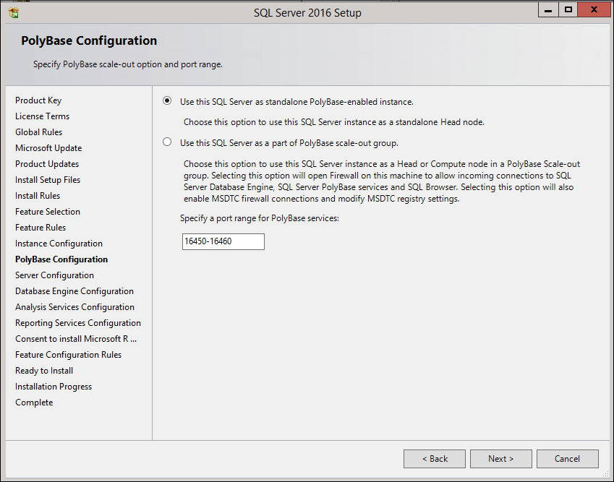
Press Next button.

Server Configuration
This section contains two tabs:

Service Accounts Tab
Before starting this section, have a domain service account created by a domain administrator for the SQL Server, and save its credentials in Secret Server. Follow the steps below:
- Change Startup Type for SQL Server Agent from “Manual” to “Automatic”
- Press Use the same account for all SQL Server services button:
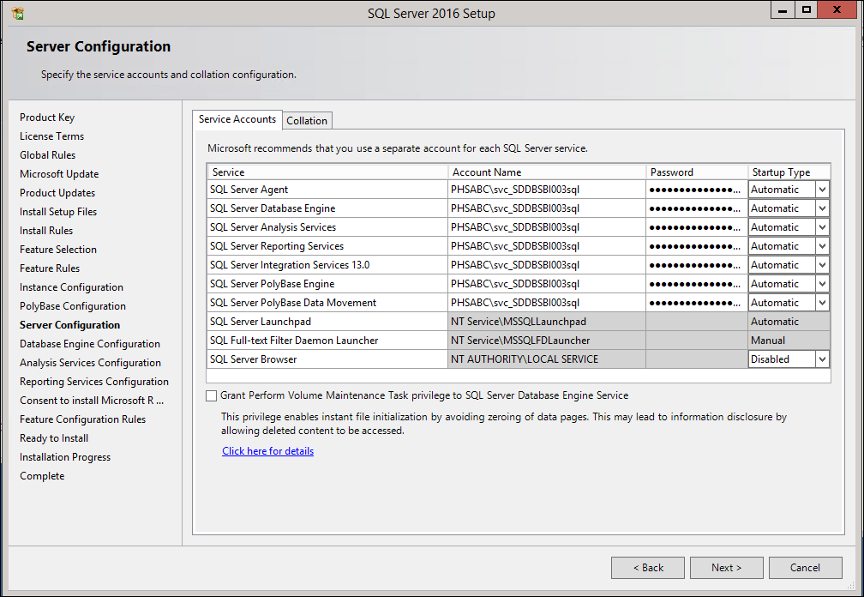

Collation Tab
Keep default settings on this tab unless the business requirements mandates a customized collation for all databases across SQL Server:
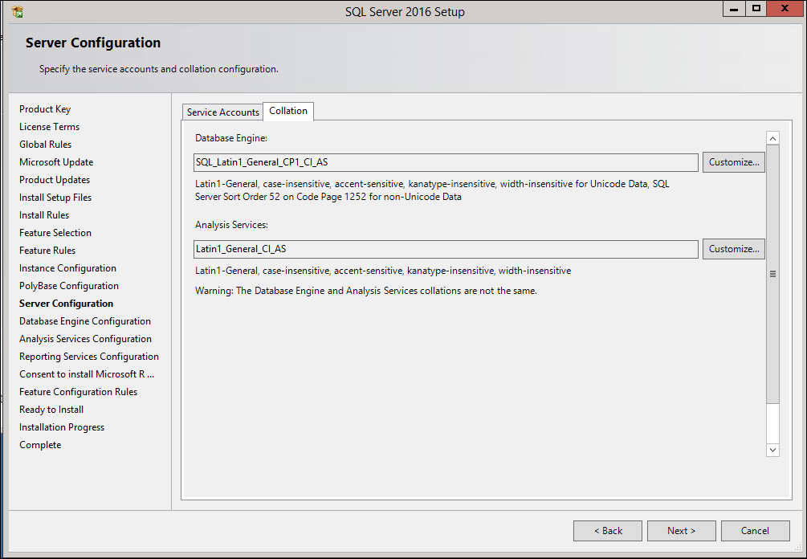

Press Next button.

Database Engine Configuration
This section contains three tabs:

Account Provisioning
Follow the steps below:
- Select Mixed Mode Authentication
- Generate a random password for SA account in Secret Server
- Enter the SA account’s password in Enter Password and Confirm Password boxes
- Press Add… button marked below, and Enter one of the domain local groups below depending on HA the SQL Server belongs to:
- VCH\SR HSSBC SQL Admin (CrossHA)
- INFOSYS\SR HSSBC SQL Admin (CrossHA)
- PHSABC\SR HSSBC SQL Admin (CrossHA)
- SFHR\SR HSSBC SQL Admin (CrossHA)
- VRHB\SR HSSBC SQL Admin (CrossHA)
- HEALTHBC\Database Services Management (HSSBC) - (DE)
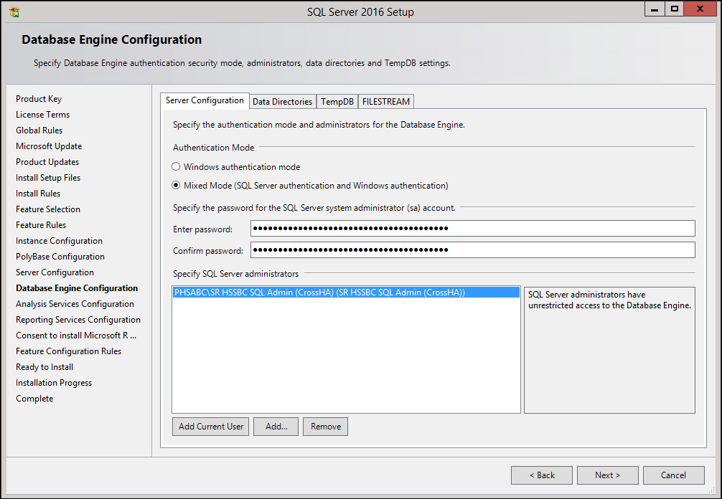

Data Directories
Make sure the following folders exist in server’s H, I, J, and K drive, and enter them in Data Directories tab accordingly:
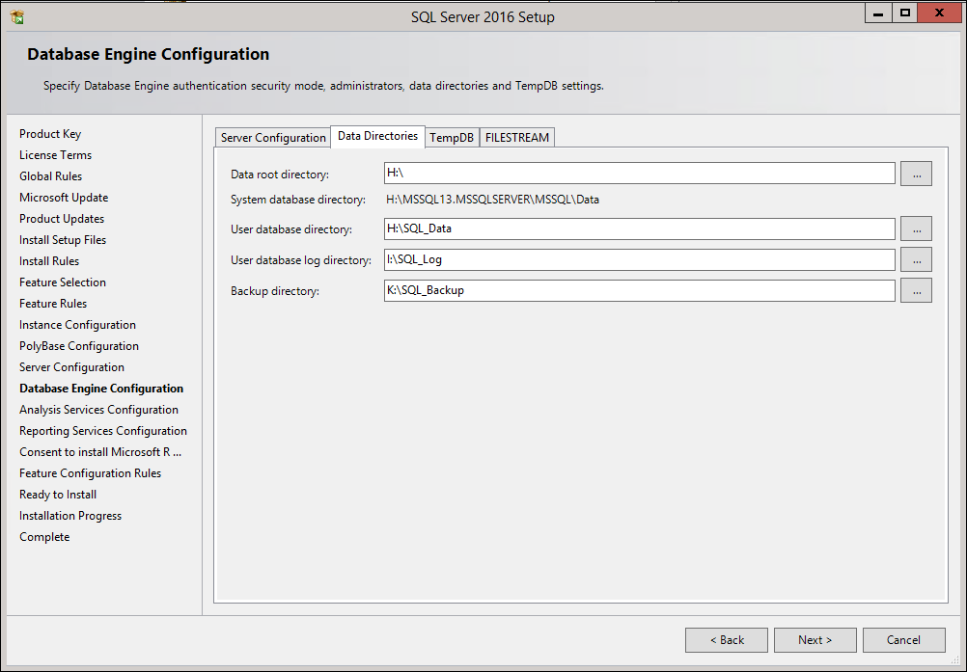

TempDB Optimization
The best practice for TempDB performance is to have as many data files as the number of CPUs, also all data files should be the same size.

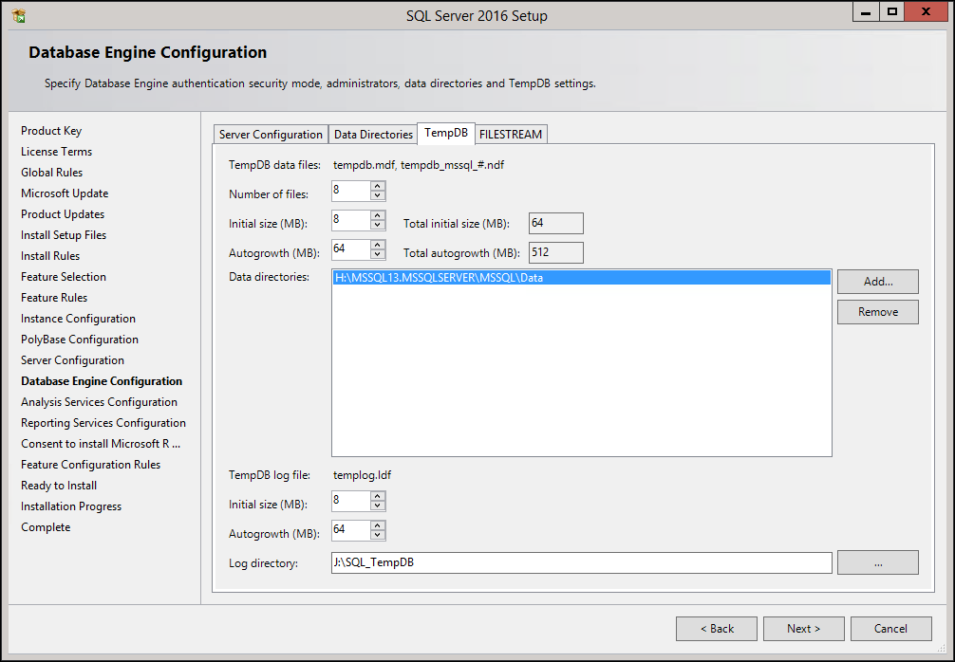
Press Next Tab, “FILESTREAM”.

With T-SQL:
Standard setup only creates one primary data file for TempDB, execute the script below to add extra data files to TempDB with proper size:
USE [master]
GO
ALTER DATABASE [tempdb] MODIFY FILE ( NAME = 'tempdev', SIZE = 100 , FILEGROWTH = 20 )
GO
ALTER DATABASE [tempdb] MODIFY FILE ( NAME = 'templog', SIZE = 20 , FILEGROWTH = 20 )
GO
ALTER DATABASE [tempdb] ADD FILE ( NAME = 'temp1', FILENAME = 'J:\SQL_TempDB\tempdb1.ndf' , SIZE = 100 , FILEGROWTH = 20 )
GO
ALTER DATABASE [tempdb] ADD FILE ( NAME = 'temp2', FILENAME = 'J:\SQL_TempDB\tempdb2.ndf' , SIZE = 100 , FILEGROWTH = 20 )
GO
.
.
.
ALTER DATABASE [tempdb] ADD FILE ( NAME = 'tempN', FILENAME = 'J:\SQL_TempDB\tempdbN.ndf' , SIZE = 100 , FILEGROWTH = 20 )
GO
Note:
Parameter “N” in the last line identifies “Number of CPUs – 1”, for example the last line for a SQL Server with 4 CPUs will be:
ALTER DATABASE [tempdb] ADD FILE ( NAME = 'temp3', FILENAME = 'J:\SQL_TempDB\tempdb3.ndf' , SIZE = 102400KB , FILEGROWTH = 20480KB )
GO

If this is second instance (e.g. clustered SQL Server), see Disk Layout for drive letters.

FILESTREAM
Keep the default settings, with FILESTREAM disabled
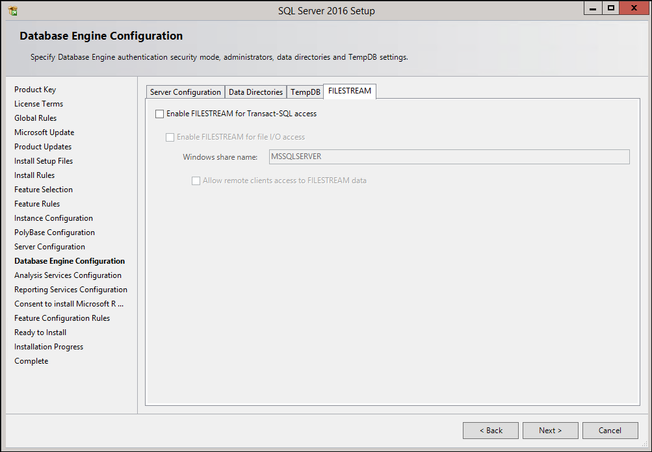
Press Next button.

Analysis Services Configuration
You will see the following configuration if Analysis services feature is selected

This section contains two tabs:

Account Provisioning
Server mode is a server property that determines which storage and memory architecture is used for that instance.
Confirm with business as to which mode, “Multidimensional and Data Mining” or “Tabular” else select the simplified modeling mode, “Tabular”.

Press Add… button marked below, and Enter one of the domain local groups below depending on HA the SQL Server belongs to:
- VCH\SR HSSBC SQL Admin (CrossHA)
- INFOSYS\SR HSSBC SQL Admin (CrossHA)
- PHSABC\SR HSSBC SQL Admin (CrossHA)
- SFHR\SR HSSBC SQL Admin (CrossHA)
- VRHB\SR HSSBC SQL Admin (CrossHA)
- HEALTHBC\Database Services Management (HSSBC) - (DE)
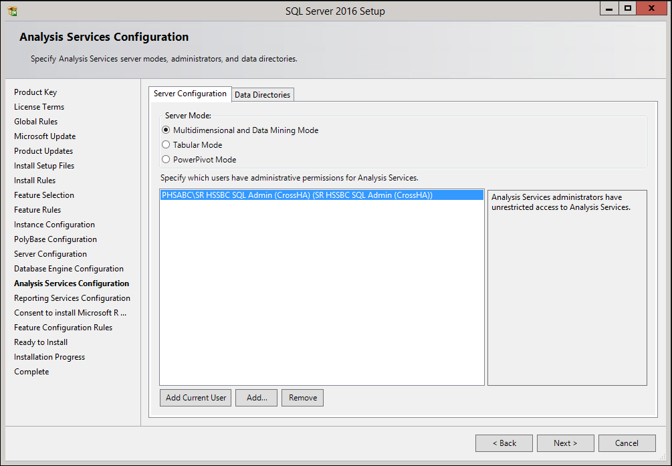

Data Directories
Make sure the following folders exist in server’s H, I, J, and K drive, and enter them in Data Directories tab accordingly:
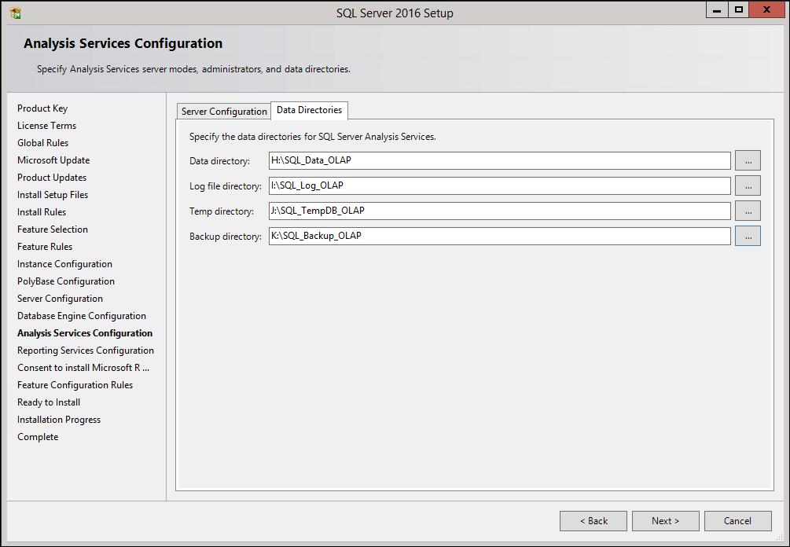

Press Next button.

Reporting Services Configuration
You will see the following configuration if Reporting Services feature is selected

Keep default setting (Install the native mode default configuration selected) as follows:
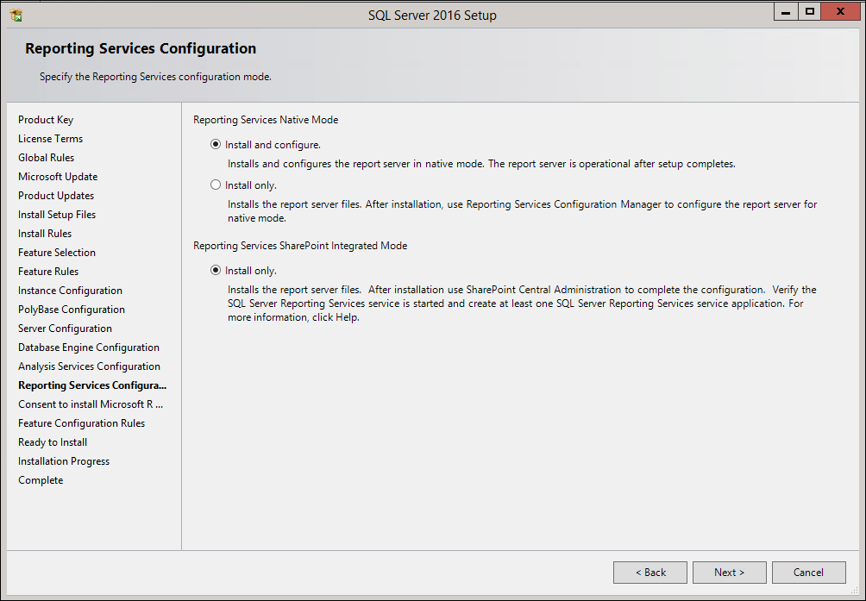

Press Next button.

Microsoft R Open feature

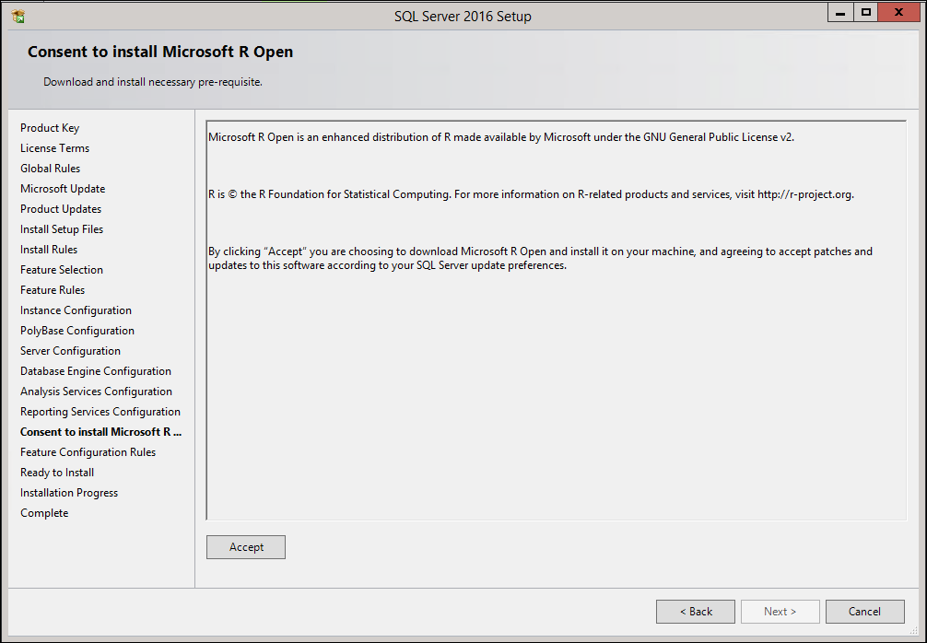
Click Accept, then click Next.

Feature Configuration Rules
Wait until Configuration Rules is completed, press Show details button and check the rules, if they are all passed as follows:
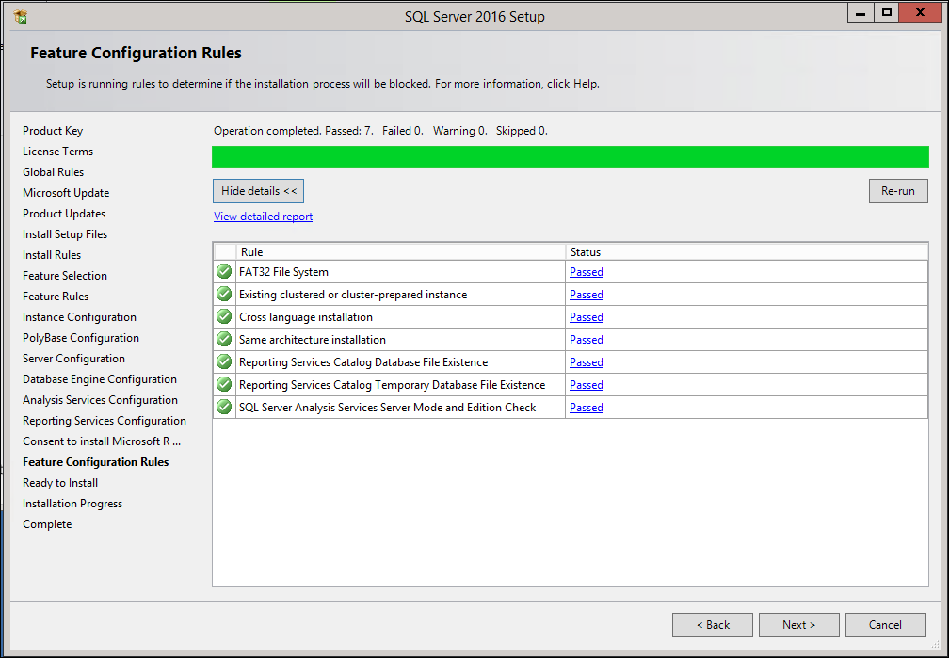

Press Next button.

Ready to Install
Press Install button:
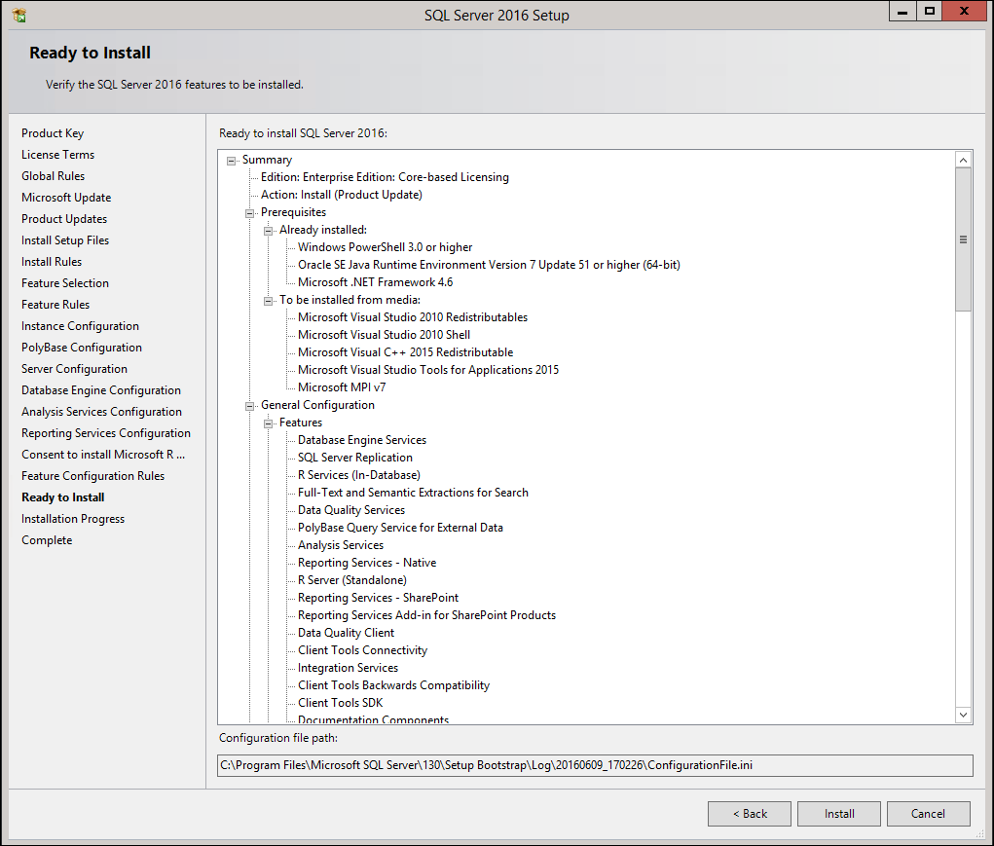

Complete
Press Close button:
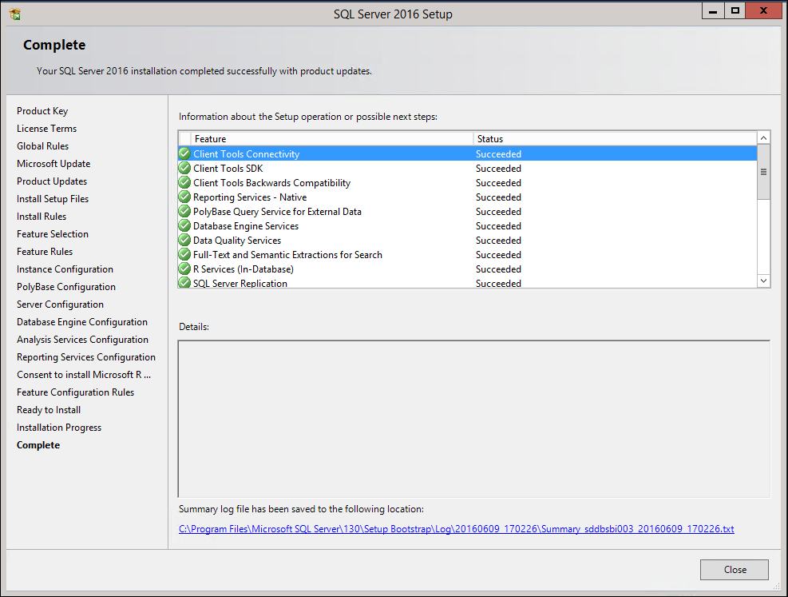

Install SQL Server Management Tools
Once SQL Server Installation Center window pops up, click on Installation link on the left, and select Install SQL Server Management Tool as shown below to download the installation file or go Database services TeamSites, for SSMS-Setup-ENU.exe.

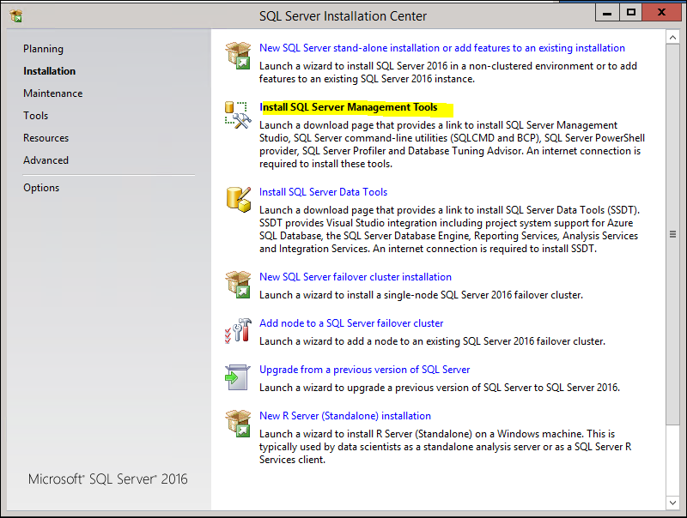

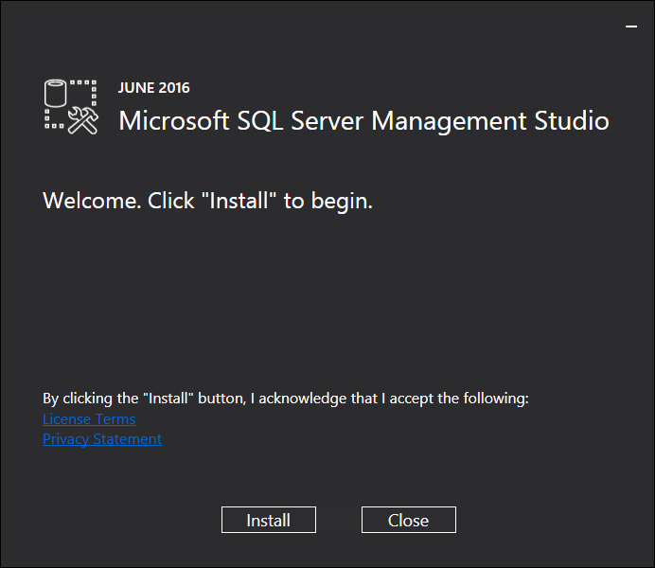
Click Install.
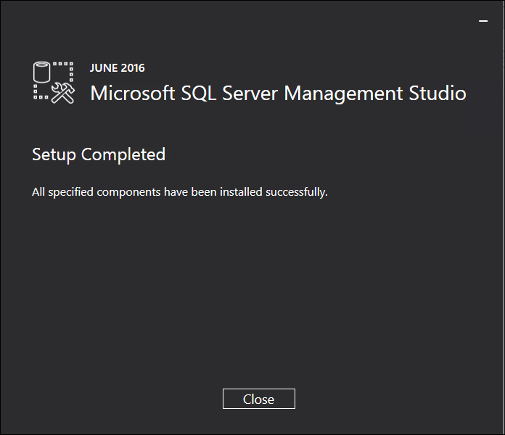
Click Close when setup completed.

Service Pack Install
Now apply latest Service Pack.

It takes a while for it to start up with no feedback, so be patient.

Pre-update checks
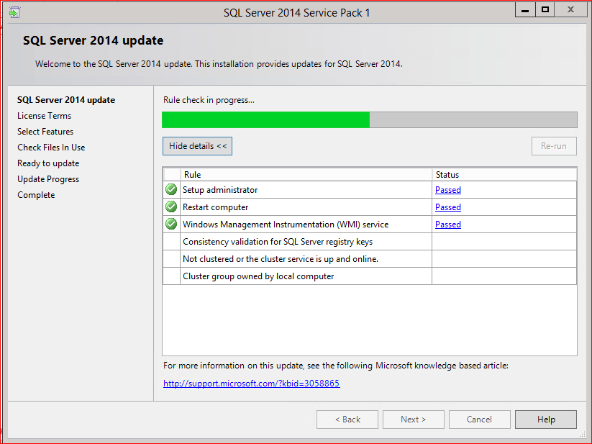
Click Next, assuming the pre-update checks pass.

Accept License Terms
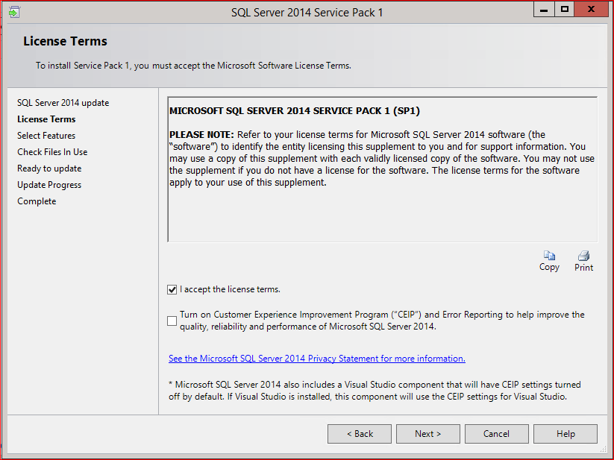
Check the appropriate box and select Next to accept the license terms.

Select Features
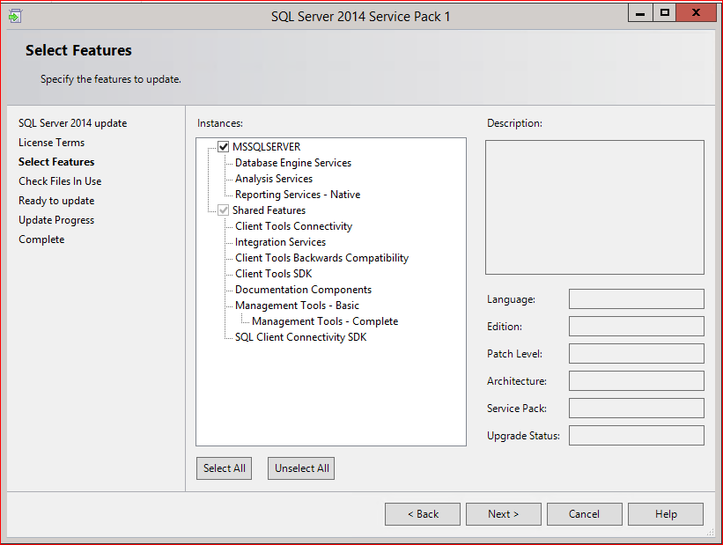
All features should be selected, as above. The only active checkbox is MSSQLSERVER anyway. Click Next.

Files in Use Check
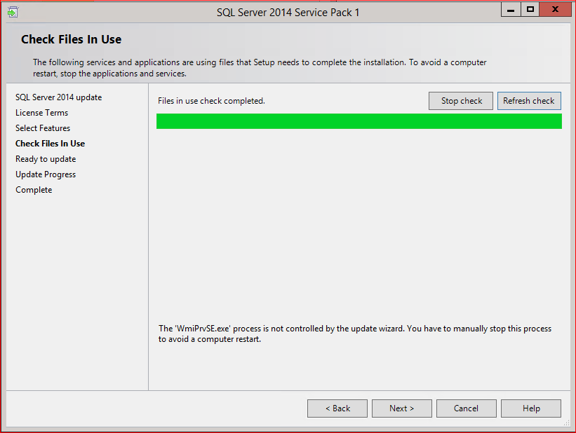
The update just checks for files in use. Assuming there are none (there shouldn’t be, since SQL 2016 is a fresh install right now), click Next.

Verify and Start
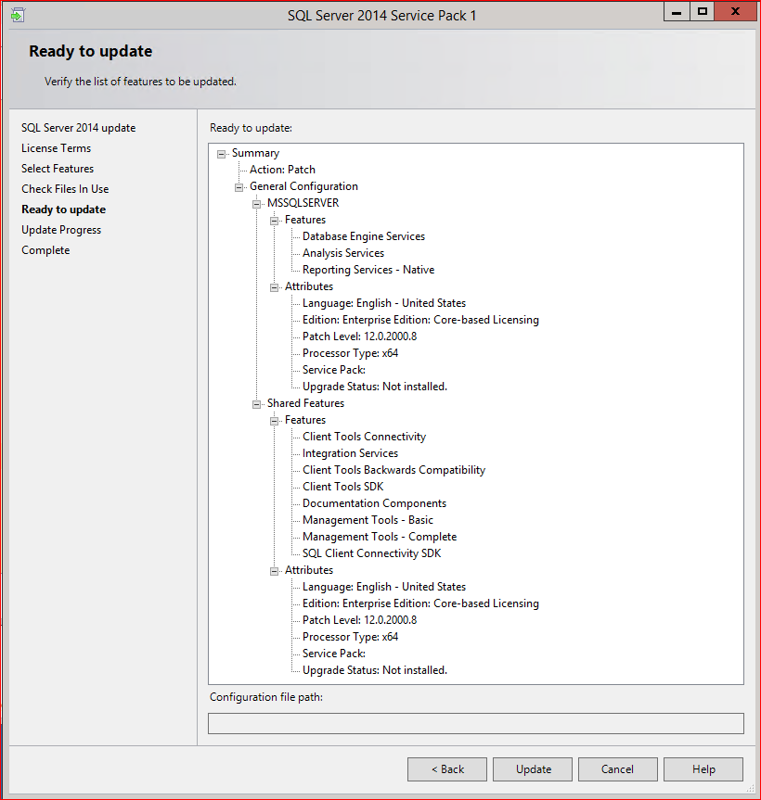
Click ‘Update’ to start the installation. The progress bar for the install won’t move, but it’s working!

Complete SP installation
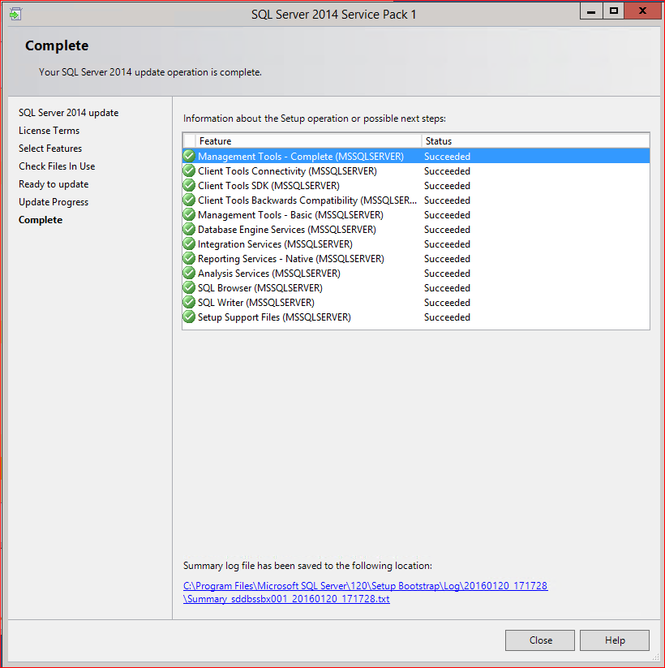
The installation is complete. Click Close.

Manual change for SSRS
Per this KB article (http://support.microsoft.com/kb/2745448), this SP may cause SSRS to not start up. Check after completion if SSRS is started, and if it is not started and will not start, do the following:
- Go to the registry key HKEY_LOCAL_MACHINE\SYSTEM\CurrentControlSet\Control.
- Create a new DWORD under Control called ServicesPipeTimeout and give it a value of 60000.
- Restart server.

SQL Server 2016 Configuration

TCP/IP Port Setting
Leave the default instance port as 1433. For additional instances use 1533, 1633, etc.

Memory Allocation
Open Server Properties window, and set the Maximum server memory to lower than maximum available physical memory as per table below:
Physical RAM | Max Server Memory
8GB | 6000
12GB | 10000
16GB | 14000
24GB | 21500
32GB | 29000
64GB | 60000

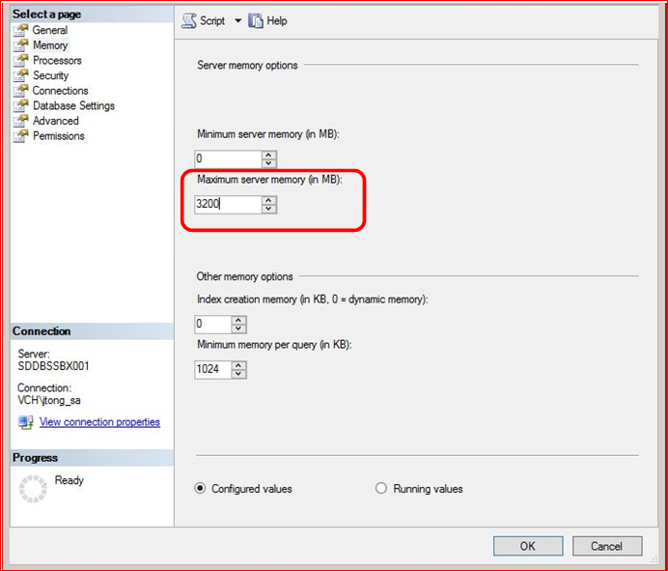

Database Settings
Check Compress backup to create compressed backups by default.
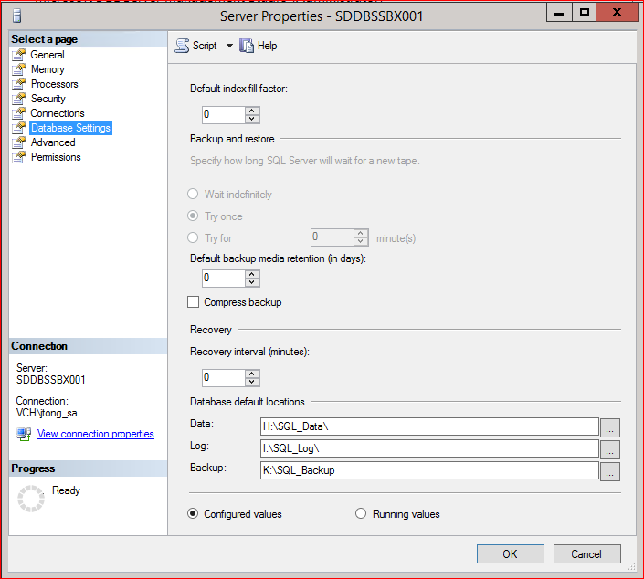

Model database optimization
New databases are created by default with the same settings as model database. Set optimal values for autogrow settings:
USE [master]
GO
ALTER DATABASE [model] MODIFY FILE ( NAME = N'modeldev', SIZE = 10240KB , FILEGROWTH = 102400KB )
GO
ALTER DATABASE [model] MODIFY FILE ( NAME = N'modellog', SIZE = 10240KB , FILEGROWTH = 51200KB )
GO

Set up Standard Maintenance
Open and execute the two scripts below from Shared Documents on Database Services team site (Maintenance Version 4) in order to create required stored procedures and jobs for standard Maintenance:
- Script1: 01_setup_database_mail_sql_agent_alert.sql
- Script2: 02_db_maint_script_package.sql

uCMDB User
uCMDB needs a login to be able to make an inventory of databases. Add the following as a login on the SQL server. It doesn’t need to be given any rights (the default Public is enough to query sysdatabases):
healthbc\SVC_HP_uCMDB

Restart SQL Services
Restart SQL Server and SQL Agent services.

Add Server to Inventory
Register Central Management Server if it has not been done already. Please note that you might not be able to do it from the server you are installing because firewall will not allow it. You can use SSMS in seth to do it.

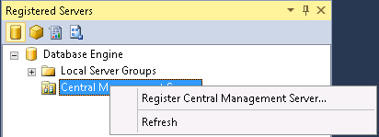

Provide server name: SPMGMTDB001\CMSINST,1433
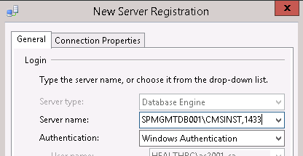

Select the CMDB folder
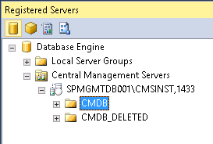

Right-click on the selected folder and select New Server Registration… as follows:
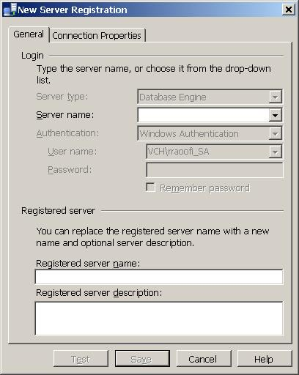
Enter the server name and in the description field put information about the database owner and the application.

Create Integration Services Catalog

Skip this step if Integration Services feature is not installed

Right click on the Integration Catalogs node and select Create Catalog.
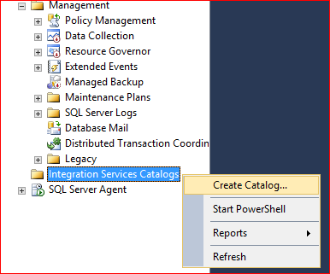

Make sure CLR Integration is not checked.
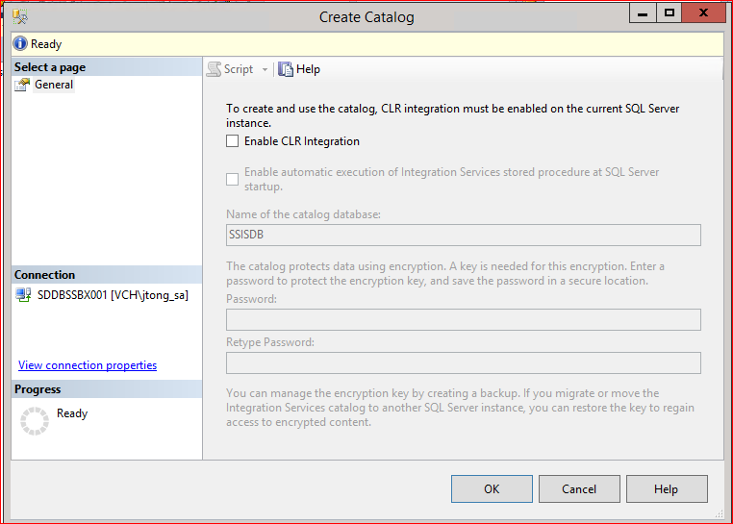
Click OK.

Reporting Services
Skip this step if Reporting Services feature is not installed.

Open Reporting Services Configuration Manager
Run Reporting Services Configuration Manager from Start menu as shown below:
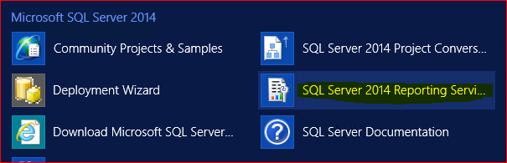
Press Connect on the connection prompt:
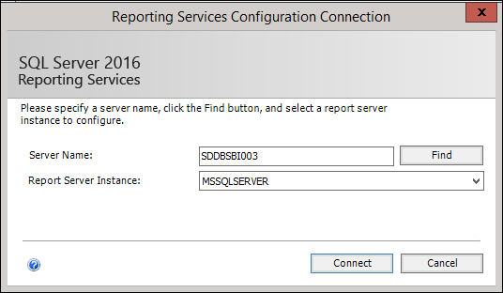

Backup Encryption Key
On the Reporting Services Configuration Manager window click Encryption Keys link on the left pane, and press Backup button as shown below:
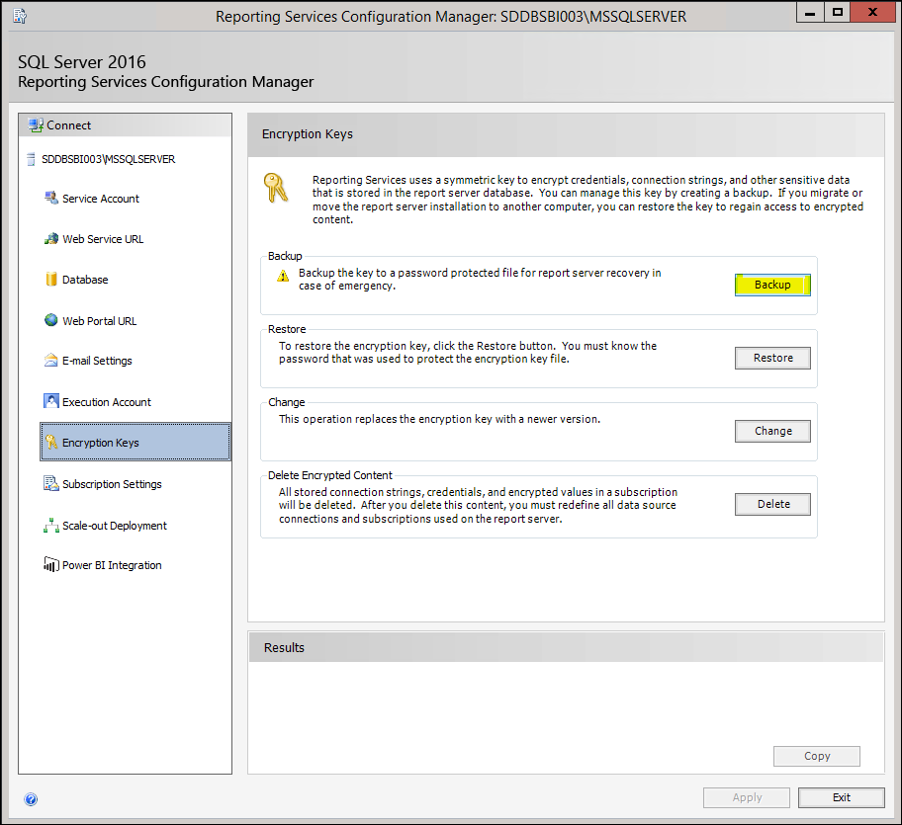
Enter “K:\SQL_Backup\<ServerName>_SSRS_Key.snk” in the File Location box, and enter the password you have generated and saved in Secret Server:
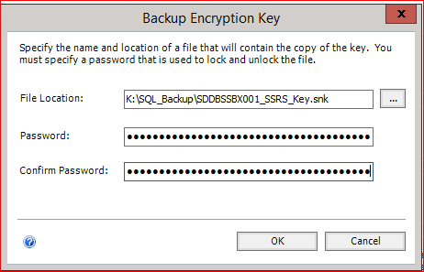
You may now press Exit button on Reporting Services Configuration Manager window.

Upload Encryption Key file to Secret Server
Upload the encryption key file created in the last step (<ServerName>_SSRS_Key.snk) to Secret Server as follows:
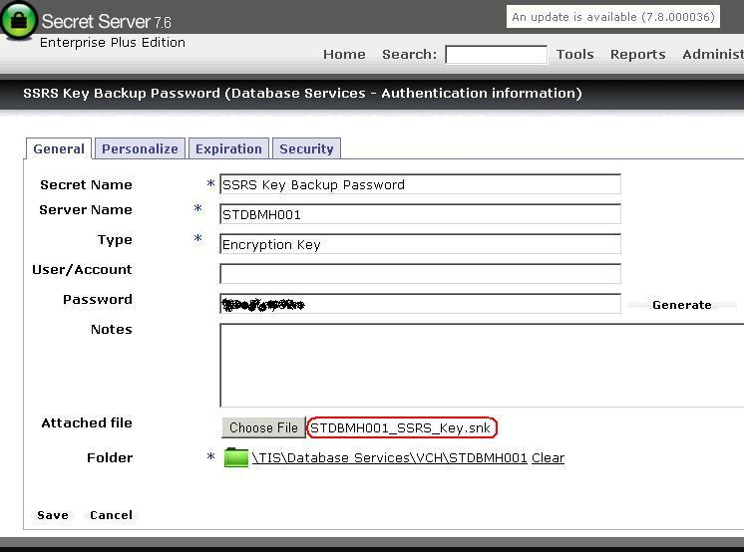
Once the file is successfully uploaded, remove the file from Report Server’s local drive (K:\SQL_Backup\).

Sharepoint

If a SQL server install was done for SharePoint, configure the following based on a MS Best Practices document (http://technet.microsoft.com/en-us/library/hh292622.aspx):
- Do not enable auto-creation of statistics.
- Set max degree of parallelism (MAXDOP) to 1 to ensure that each request is served by a single SQL Server process.

